Lab assignment_3.2

## NAME:V.NITHYA

## HALL TICKET NO:2403A52346

TASK 1:

Write a python program to find compound interest by using functions

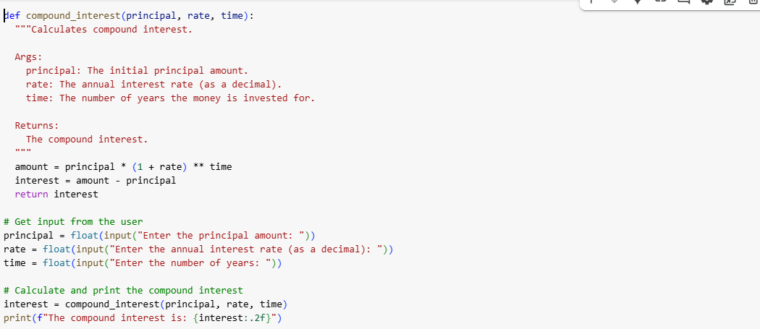

OUTPUT:

EXPLANATION:

TASK 2:

Write a python program in python in calculate average,median and mode of a list of numbers using functions

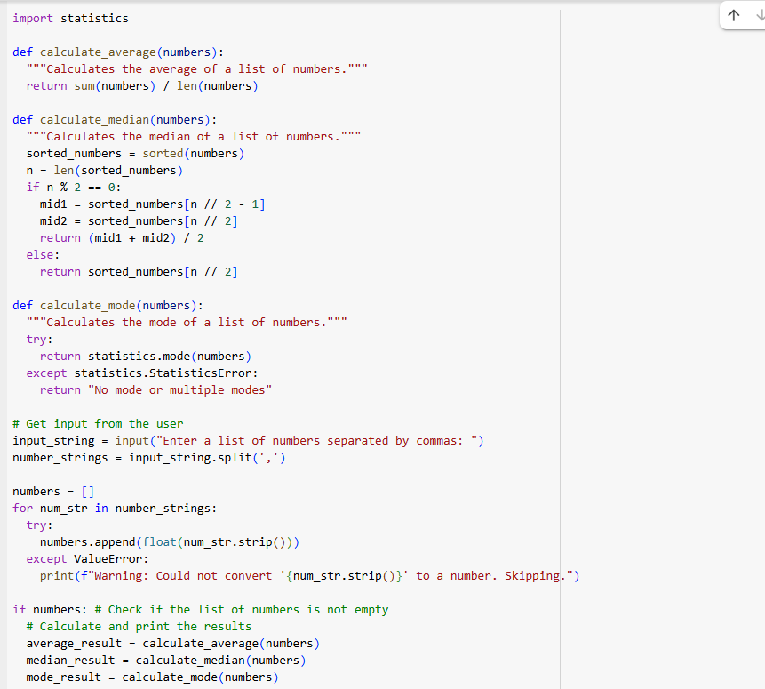

OUTPUT:

EXPLANATION:

TASK 3:

Write a python program with input and output to convert_to_binary(num) using function with multiple examples

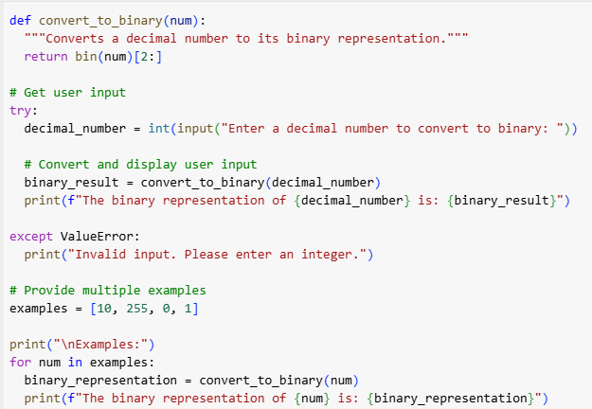

OUTPUT:

EXPLANATION:

TASK 4:

Write a python program with input and output to convert_to_binary(num) using function with multiple examples

OUTPUT:

EXPLANATION:

TASK 5:

Write a python program to convert degree celcius to farenheit using functions

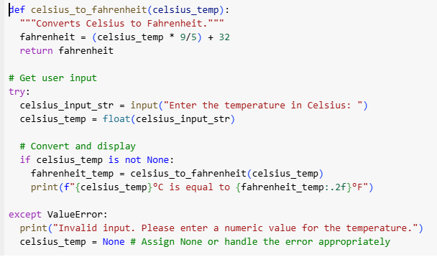

OUTPUT:

EXPLANATION:

